**DAILY ONLINE ACTIVITIES SUMMARY**

|  |  |  |  |  |  |  |  |  |
| --- | --- | --- | --- | --- | --- | --- | --- | --- |
| **Date:** | **01/06/2020** | | | | | **Name:** | **Lavanya D M** | |
| **Sem & Sec** | **4th & ‘A’** | | | | | **USN:** | **4al18cs041** | |
| **Online Test Summary** | | | | | | | | |
| **Subject** | | **Maths** | | | | | | |
| **Max. Marks** | | **30** | | **Score** | | | **16** | |
| **Certification Course Summary** | | | | | | | | |
| **Course** | **Python** | | | | | | | |
| **Certificate Provider** | | | **Bitdegree** | | **Duration** | | | **1WEEK,3hr** |
| **Coding Challenges** | | | | | | | | |
| **Problem Statement:1)**write a java programto calculate the distance between points p1 and p2 and return the value in double..  **2**) Given an array arr[] of size N and an integer K. The task is to find the count of subarrays such that each subarray has exactly K distinct elements.  **3)** Given an array of positive integers. Write a C Program to find the leaders in the array. | | | | | | | | |
| **Status: complied** | | | | | | | | |
| **Uploaded the report in Github** | | | | | **yes** | | | |
| **If yes Repository name** | | | | | <https://github.com/lavanyamurthi/lockdown-coding> | | | |
| **Uploaded the report in slack** | | | | | **yes** | | | |

Online Test Details: (Attach the snapshot and briefly write the report for the same)

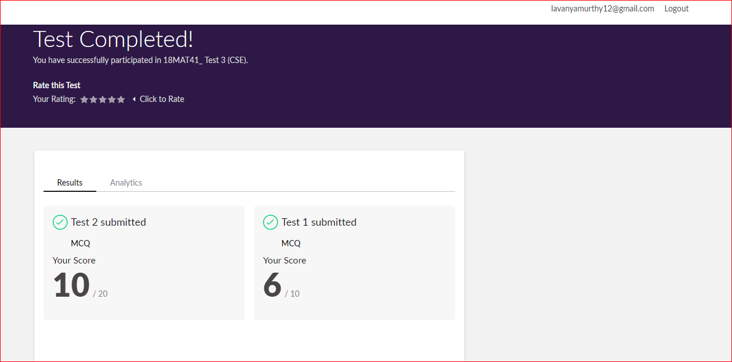

Certification Course Details: (Attach the snapshot and briefly write the report for the same)



Coding Challenges Details: (Attach the snapshot and briefly write the report for the same)

Problem 1 : Define a class Point with two fields x and y each of type double. Also , define a method distance(Point p1, Point p2) tocalculate the distance between points p1 and p2 and return the value in double.. Use Math.sqrt( ) to calculate the square root.

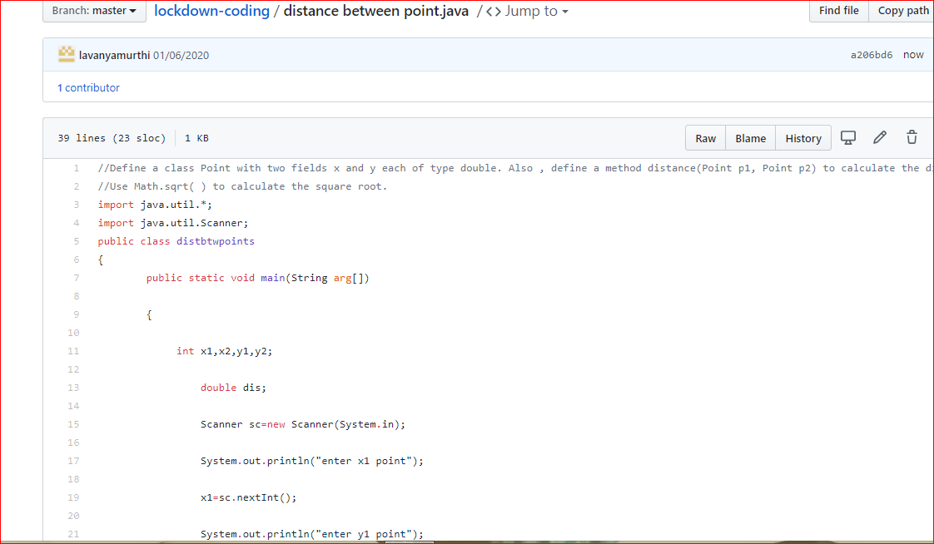

Problem 2: Given an array arr[] of size N and an integer K. The task is to find the count of subarrays such that each subarray has exactly K distinct elements.

Examples: Input: arr[] = {2, 1, 2, 1, 6}, K = 2 Output: 7 {2, 1}, {1, 2}, {2, 1}, {1, 6}, {2, 1, 2}, {1, 2, 1} and {2, 1, 2, 1} are the only valid subarrays

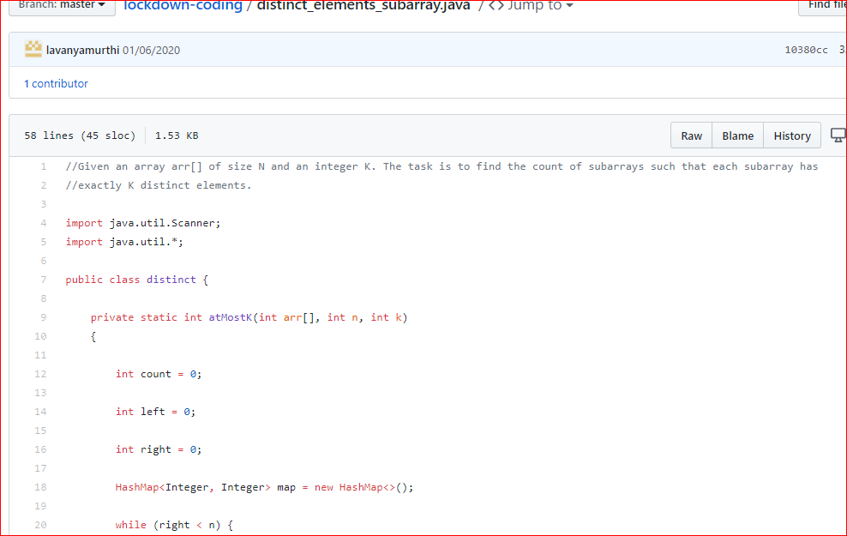

**Problem 3:** Given an array of positive integers. Write a C Program to find the leaders in the array.

**Note:** An element of array is leader if it is greater than or equal to all the elements to its right side. Also, the rightmost element is always a leader.

**Input:**  
The first line of input contains an integer T denoting the number of test cases. The description of T test cases follows.  
The first line of each test case contains a single integer N denoting the size of array.  
The second line contains N space-separated integers A1, A2, ..., AN denoting the elements of the array.

**Output:**  
Print all the leaders.

**Constraints:**  
1 <= T <= 100  
1 <= N <= 107  
0 <= Ai <= 107

**Example:**

**Input:**  
3  
6  
16 17 4 3 5 2  
5  
1 2 3 4 0  
5  
7 4 5 7 3

**Output:**  
17 5 2  
4 0  
7 7 3  
**Explanation:  
Testcase 3:** All elements on the right of 7 (at index 0) are smaller than or equal to 7. Also, all the elements of right side of 7 (at index 3) are smaller than 7. And, the last element 3 is itself a leader since no elements are on its right.

